# Analyzing HAC Reduction Penalty Likelihood

The third of the Affordable Care Act's quality incentive programs, the hospital acquired-condition (HAC) reduction program, is set to go into effect in FY 2015. Under the program, the lowest performing quartile of hospitals on measures of hospital-acquired conditions will suffer a penalty of 1 percent on their total Medicare inpatient payments from the Centers for Medicare & Medicaid Services (CMS). This program aims to incentivize the reduction of these costly and often fatal harm events, estimated to cause 99,000 deaths and add as much as $33 billion to the nation's healthcare costs annually.[1] While all agree that this is a worthy goal, some have suggested that the program's penalties do not effectively measure differences in quality. Notably the American Hospital Association (AHA) and others have raised concerns that teaching hospitals and hospitals of 400 beds or larger will be penalized disproportionately.[2] If this is the case, the program may have the unintentional consequence of systematically taking funds from hospitals that already face resource shortages, leading to poorer outcomes for vulnerable communities.

The Essential Hospitals Institute is interested in determining the effect of this program on the members of America's Essential Hospitals specifically and, more generally, those hospitals that have made it their mission to care for the nation’s vulnerable populations. We begin by investigating the concerns raised by the AHA using CMS' own predictions recently released in the FY2015 Inpatient Prospective Payment Proposed (IPPS) rule. We then analyze the effect of the program on members of America's Essential Hospitals. Finally, we explore further relationships between patient acuity and HAC reduction program penalties.

## Methods

This study was conducted using preliminary data from CMS' FY2015 IPPS rule. Additionally, we utilized demographic data gathered as part of the AHA annual survey of members, to examine bivariate relationships between program penalties and size, teaching status, membership in America's Essential Hospitals, and transfer adjusted case-mix index. *P* values for all statistical tests are 2-tailed and alpha is set at 0.01. Analyses were performed using the R statistical package version 3.0.2 and R Studio version 0.98.501.

## Results

Recently released preliminary data from CMS' FY2015 Inpatient Prospective Payment Proposed rule estimates that 772 hospitals will be penalized under the program with a one percent reduction in hospital payments from CMS.

This estimation shows that 38.12 percent of hospitals with 400 beds or more will be penalized. Teaching status, defined in our analysis as being a member of the Council of Teaching Hospitals (COTH), faced penalties at a rate of 54.47 percent. A chi-square test of independence was performed to examine the relationship between a hospital size of 400 beds or greater and penalties under the HAC reduction program. The relation between these variables was significant, X2(1, N = 3263) = 68.17, p < .01. Larger hospitals are more likely to be penalized under the program.

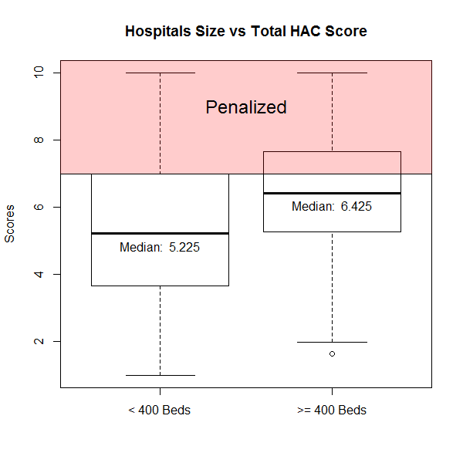

**Figure 1: Comparison of Penalties: Hospitals with**

**400 beds or more**

Data obtained for period from xxx, 20xx to xxx, 20xx

A similar chi-square test examining the relationship between teaching status and penalties also returned significant results, X2(1, N = 3263) = 150.10, p < .01, indicating that teaching hospitals are also more likely to be penalized under the program.

Given these findings it is not surprising that essential hospitals, comprised of many large academic medical centers, also prove to be disproportionately affected by these penalties. Nearly 50 percent of essential hospitals are facing penalties under the program, leading to concern that its methodology is leading to a systematic punishment of those hospitals that treat the nation's sickest patients.

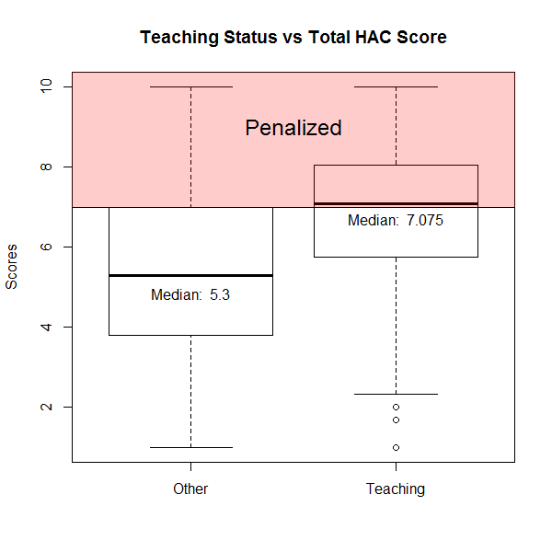

**Figure 2: Comparison of Penalties: Teaching Hospitals**

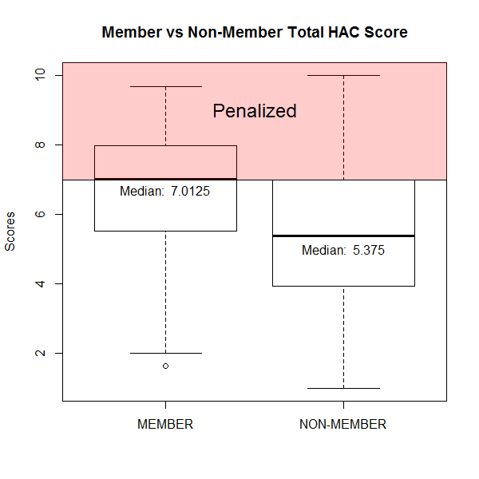

**Figure 3: Comparison of Penalties: America's Essential Hospital Membership**

Data obtained for period from xxx, 20xx to xxx, 20xx,

To investigate this concern, we examined estimated penalties under the program with respect to CMS' reported transfer adjusted case-mix index (CMI), a measure of patient acuity. After dividing hospitals into their respective CMI quartiles, a relationship between patient acuity and penalization can be seen. Furthermore, the odds of a hospital in the upper quartile of CMI being penalized were 1.81 times that of those falling below that threshold.

## Discussion

**Table 1: Comparison of Penalties: Teaching Hospitals**

|  |  |  |  |  |
| --- | --- | --- | --- | --- |
| Transfer Adjusted Case-Mix Index Grouper V31 | | | | |
|  | 1st Quartile | 2nd Quartile | 3rd Quartile | 4th Quartile |
| Not Penalized | 686 | 641 | 628 | 565 |
| Penalized | 134 | 166 | 188 | 255 |
| Percent Penalized | 16.34% | 20.57% | 23.04% | 31.10% |

Note: Data obtained from CMS FY 2014 Impact File, data collected from FY 2010-2011 CMS Cost Reports

This analysis found that teaching hospitals, hospitals with more than 400 beds, and those hospitals treating patients with a higher average acuity will be penalized at higher rates than other institutions. These same hospitals are more likely to provide care to a high proportion of Medicaid and uninsured patients, who have been shown to enter hospitals with higher acuity and experience higher rates of complications.[3] Such a disparity in the application of penalties in the HAC reduction program is very concerning for essential hospitals and should be considered with care by policymakers.

Higher penalties under CMS’ new quality incentive programs will place further financial stress on essential hospitals, compounding disparities already present under Medicare’s limited payment policy for HACs.[4] Not only do these hospitals face chronic resource constraints, with average margins hovering under 2 percent[5], they are facing cuts to DSH funding without strong evidence that the costs associated with treating low-income patients will decrease. Financial realities limit the abilities of essential hospitals to conduct quality improvement initiatives, leading to lower baseline performance measures and slower improvement on quality measures.[6]

Legislators and policymakers should give careful consideration to the unique needs of vulnerable patients and the essential hospitals who care for them. Further research is needed to more fully examine the links between patient acuity and the various measures covered by the HAC reduction program, both at its launch and those added in the future. Additionally, these data suggest that current risk adjustment efforts in the program fail to create a balanced measure of quality that is useful for comparison between institutions. All of these factors have the potential to worsen disparities and limit access to care for vulnerable patients.

1. Scott RD. The Direct Medical Costs of Healthcare-associated Infections in U.S. Hospitals and the Benefits of Prevention. Division of Healthcare Quality Promotion, National Center for Preparedness, Detection, and Control of Infectious Diseases, Coordinating Center for Infectious Diseases, Centers for Disease Control and Prevention. March 2009.
2. Letter to Marilyn Tavenner, Administrator, Centers for Medicare & Medicaid Services, from the American Hospital Association, June 20, 2013, retrieved from http://www.aha.org/advocacy-issues/letter/2013/130620-cl-cms-1599p.pdf
3. Waits SA, Reames BN, Sheetz KH, Englesbe MJ, et al. Anticipating the Effects of Medicaid Expansion on Surgical Care. *JAMA Surgery.* 2014; [Epub ahead of print]: doi: 10.1001/jamasurg.2014.222
4. McHugh M, Martin TC, Orwat J, et al. Medicare’s Policy to Limit Payment for Hospital-acquired Conditions: The Impact on Safety Net Providers*.* 2011; 22: 638-647
5. Regenstein M, Huang J. Stresses to the safety net: The Public Hospital Perspective. Kaiser Family Foundation*.* 2005
6. Werner RM, Goldman EG, Dudley RA. Comparison of Change in Quality of Care between Safety-Net and Non-Safety-Net Hospitals*. JAMA*. 2008; 299(18): 2180-2187